**The University of Azad Jammu and Kashmir**



**Name : Nida Hameed**

**Session : 2024-2028**

**Course Title: CA&LD**

**Submitted to : Engr . Sidra Rafique**

**Half Adder**

**Half Adder simple circuit**

**Procedure: How I Created a Simple Half Adder Circuit**

1. **Objective:**I wanted to make a half adder that adds two 1-bit inputs (A and B) and gives me the sum and carry outputs using a simple circuit.
2. **Understanding the Half Adder:**I know the half adder takes inputs A and B and produces:

* Sum = A XOR B
* Carry = A AND B

Since this is a simple circuit, I directly used XOR and AND gates for these outputs.

1. **Building the Circuit**:

* I connected inputs A and B directly to an XOR gate to get the Sum output.
* Then I connected inputs A and B to an AND gate to get the Carry output.

1. **Testing the Circuit:**I tested all possible inputs:

* A=0, B=0 → Sum=0, Carry=0
* A=0, B=1 → Sum=1, Carry=0
* A=1, B=0 → Sum=1, Carry=0
* A=1, B=1 → Sum=0, Carry=1

The outputs were exactly what I expected.

1. **Conclusion:**By using the XOR and AND gates directly, I built a simple and efficient half adder. This helped me understand how these basic gates work together to perform addition.

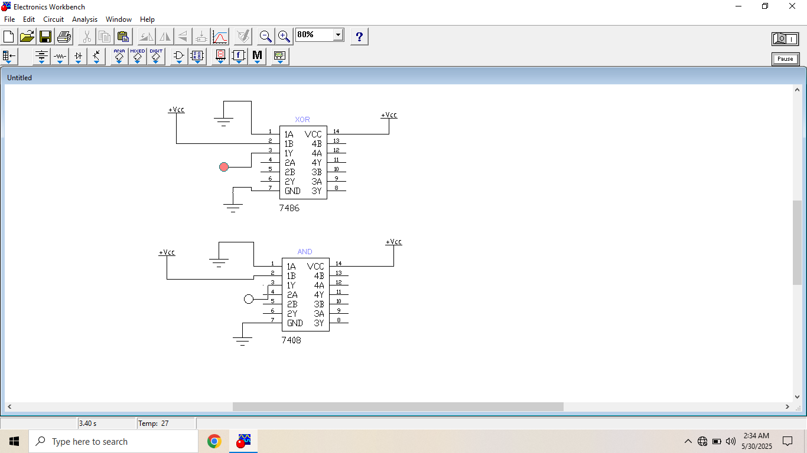

**Hardware circuit:**

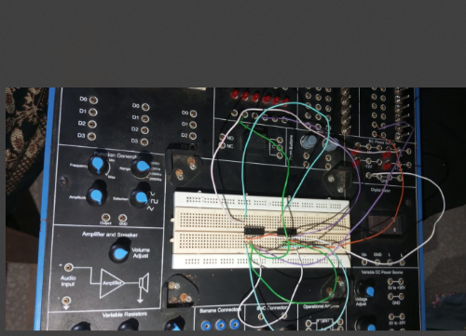

**Half Adder Complicated circuit**

**Procedure: How I Created a Half Adder Using NOT, AND, and** **OR Gates**

1. **Objective:**I wanted to build a half adder that adds two inputs and outputs sum and carry, but only using NOT, AND, and OR gates because XOR gate wasn’t allowed.
2. **Understanding the Logic:**I know a half adder has two inputs (A and B) and two outputs:

* Sum = A XOR B
* Carry = A AND B

Since I can’t use XOR directly, I needed to express XOR using only NOT, AND, and OR gates.

**3.Building the Circuit:**

* I connected input A to a NOT gate to get A’, and input B to AND gate.
* Then I connected input A with AND gate and input B with NOT gate.
* Then I ANDed A’ with B, and A with B’.
* I ORed the results of those two AND gates to produce the sum output.
* For carry, I simply ANDed A and B directly.

**4. Testing the Circuit:**I tested the circuit for all possible inputs:

* For A=0, B=0 → Sum=0, Carry=0
* For A=0, B=1 → Sum=1, Carry=0
* For A=1, B=0 → Sum=1, Carry=0
* For A=1, B=1 → Sum=0, Carry=1

Everything worked exactly as expected.

**5.Conclusion:**By building the half adder using NOT, AND, and OR gates, I learned how to create XOR functionality from basic gates. This helped me understand how complex logic circuits are made from simple parts.

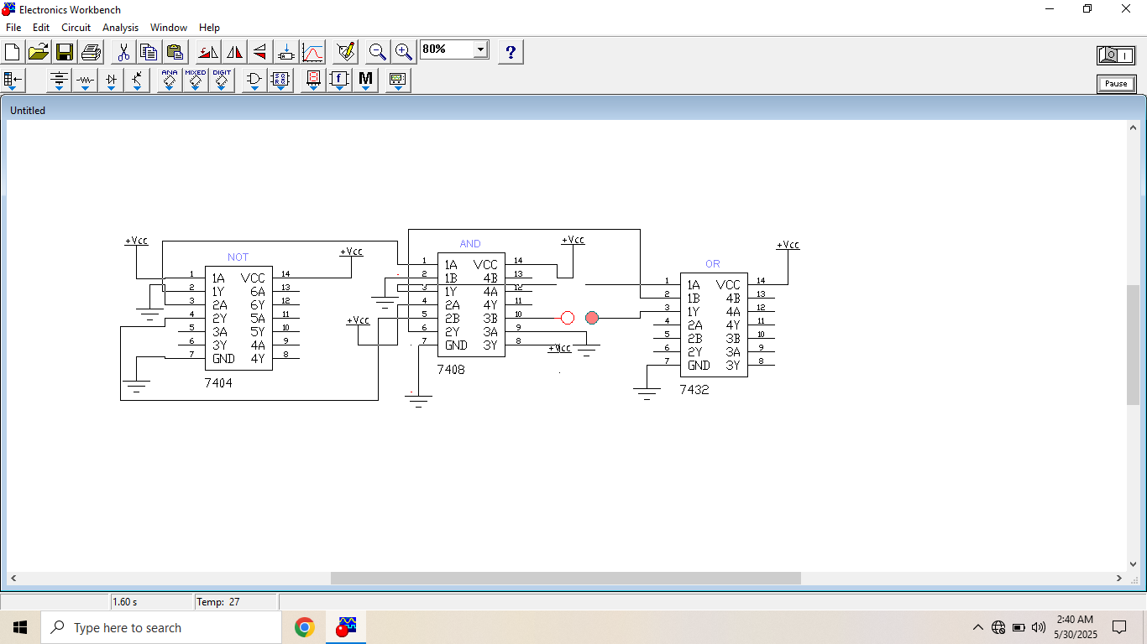

**Hardware circuit:**

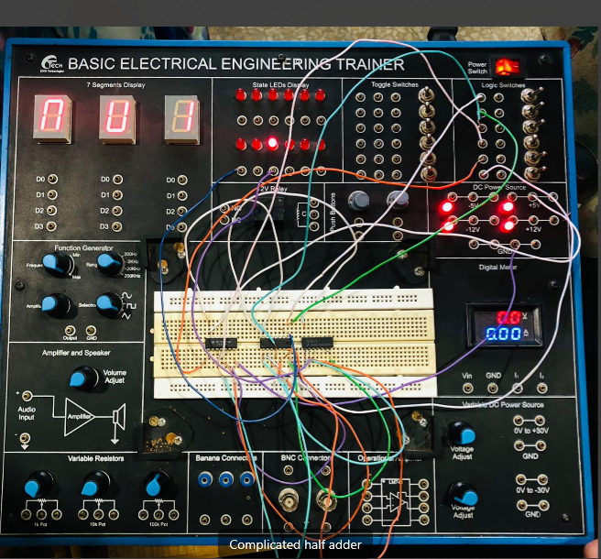

Table:

|  |  |  |  |  |  |  |  |
| --- | --- | --- | --- | --- | --- | --- | --- |
| A | B | A’ | B’ | A’.B | A.B’ | A’.B+A.B’(Sum) | A.B(carry) |
| 1 | 1 | 0 | 0 | 0 | 0 | 0 | 1 |
| 1 | 0 | 0 | 1 | 0 | 1 | 1 | 0 |
| 0 | 1 | 1 | 0 | 1 | 0 | 1 | 0 |
| 0 | 0 | 1 | 1 | 0 | 0 | 0 | 0 |